Privacy-Preserving Federated Learning Framework for Collaborative Industrial Robotics in Industry 5.0

Article Info |  | ABSTRACT
Article history:  Received Jun 9, 2018  Revised Nov 20, 2018  Accepted Dec 11, 2018 |  | Smart robots are becoming indispensable in today’s factories because they can learn on the fly adapt to changing tasks and work alongside humans—sometimes even passing over a freshly welded part without missing a beat. Traditional centralized learning usually means gathering huge volumes of operational data in a single location which can strain the network and expose sensitive details—like a user’s exact GPS coordinates—to privacy risks. By presenting a Federated Learning (FL) framework this paper addresses these issues and enables industrial robots to train shared models while securely storing raw data such as sensor readings on each machine. Each robot processes the data it collects independently before sending only a securely encrypted model update to the central server where it is aggregated. Hierarchical aggregation and differential privacy are combined in the suggested framework to improve data security and expedite communication such as by eliminating unnecessary steps to speed up messages. Tests show that compared to centralized approaches such as locking a notebook in a desk rather than leaving it out in the open the system learns more quickly achieves higher accuracy and protects data. This study opens the door to a more connected reliable Industry 5.0 by demonstrating how Federated Learning makes it possible for industrial robots such as machines to collaborate securely scalable and intelligently without ever leaving the factory floor.
Keywords:
Federated Learning
Industrial Robotics
Edge Computing
Privacy Preservation
Smart Manufacturing
Corresponding Author:

- INTRODUCTION
Industry 5.0 where intelligent machines and humans collaborate to create production spaces that are adaptable effective and precisely calibrated—like a workshop humming with smooth synchronized motion—is rapidly replacing traditional manufacturing. Industrial robots are now autonomous agents that learn from their environment adapt to changing conditions and collaborate with other machines in real time—sometimes keeping up with the hum of a conveyor belt. They are no longer merely programmed tools. Robots must use a far larger pool of operational data collected from various production floors where the hum of machines never stops in order to achieve this level of intelligence [1,2].
This type of learning has historically depended on centralized machine learning where information from dozens of robots is collected and processed in a single location akin to a bustling control room filled with workstations. It can work but there are significant obstacles to overcome such as attempting to carry a bucket that is already leaking. Since sensitive manufacturing specifications such as precise machine settings or other proprietary information may be contained in raw operational data centralized systems may compromise privacy. In addition they are susceptible to a single point of failure network congestion and communication costs all of which lower scalability and reliability in industrial settings [3 4].
In order to tackle these challenges, researchers are utilizing the Federated Learning (FL) approach - a decentralized mechanism in which multiple robots collaboratively learn in order to improve a shared model while keeping their data private [5]. More specifically, each robot will train locally on its own data and just send model updates to a general server, where the model transferrals are combined to improve the global model. Using FL to complement robots creates a privacy-preserving, bandwidth-efficient, and scalable learning paradigm that suits today’s connected industrial systems [6].
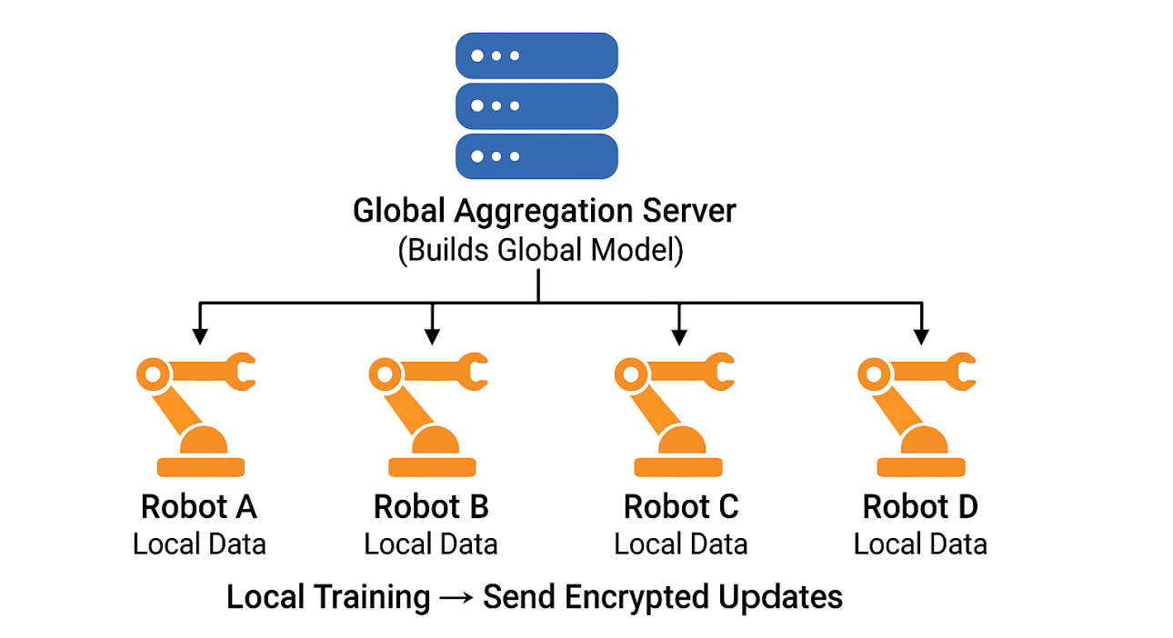
Figure 1: Concept of Federated Learning in Industrial
However, the implementation of FL in manufacturing settings is not simple. Often times, robots would operate in varying conditions, which would result in biased or not the same data distributions that may slow down learning. The concept of federated learning in industrial settings is illustrated in Figure 1. In addition, robots may not be able to communicate with a server in a reliable and timely fashion and a trade-off between model performance, privacy, and efficiency would continue to be an important issue [7].
In response to these constraints, a Federated Learning framework is presented that supports cooperation between autonomous industrial robots while safeguarding sensitive data. The framework in question pairs the use of hierarchical aggregation to decrease communications and differential privacy to protect local data while training. All robots can be part of the global learning without publically releasing their local information.
Experimental results prove faster training, better accuracy, and stronger privacy for the model as opposed to the normal baseline centralization method of training that is prevalent today. Edge computing together with secure model aggregation indicated in this study how Federated Learning could be a facilitator of trustworthy and cooperative robotic intelligence — a step closer to achieving even safer, more intelligent, and connected Industry 5.0 manufacturing environments [8].

- LITERATURE REVIEW
A thorough analysis of FL prospects in collaborative and networked industrial systems was provided by [9] revealing significant obstacles such as data diversity communication cost and trust governance in industrial applications. The potential of FL in collaborative networked industrial systems was thoroughly examined and obstacles like high communication costs highly diverse data and the challenging problem of trust governance in actual factory settings were identified.
[10] A communication-efficient FL framework for identifying industrial human-robot interaction CEFHRI was proposed. This study supports our focus on communication impracticality when we use local aggregation and selectively generate updates. Their attempts to decrease communication rounds and adjust update frequency based on the task semantics were useful strategies to ensure model performance when communication is a limited resource and connectivity is sporadic.
[11] Introduced an edge computing structure based on federated learning for Industrial IoT applications, studying latency issues, model synchronization, and methods to handle non-IID sensor data, which is very common in industrial environments. Their findings on edge-server coordination and synchronization guidelines motivated our design of local edge aggregators and aided in our selection of asynchronous/periodic synchronization heuristics for reliable convergence across heterogeneous robots.
[12] Created a Federated Learning (FL) pipeline implemented with ROS2 framework aimed at enabling collaborative learning across robotic agents, which resulted in improvements in generalization to navigation and manipultation tasks while maintaining data locality. Their ROS2 integrated pipeline and multi-agent orchestration helped guide our pragmatic considerations for deploying FL to real robotic fleets (communication protocols, fault tolerance, and model distribution).
Localized optimization in tandem with global model aggregation can result in coordinated control that is computationally efficient at the central server. [13] Motivated us to create compact local client models that can be aggregated at the global prompt for model aggregation-based coordinated control. They have studied federated variants of distributed multi-robot arm trajectory optimization that we summarize below.
Putting all of these pieces together leads to three enduring needs in industrial/robotic FL: (1) strong privacy guarantees (e.g., DP, encryption) without incurring undue accuracy loss, (2) aggregation strategies that are cognizant of communication and latency limitations when working in wireless, resource-constrained environments, and (3) a practical approach to integration with (or using) robotics middleware and edge controllers for fully operational deployment. Our schematic approach directly builds on these three points by (i) leveraging homomorphic encryption with differential privacy to minimize leakage while also attempting to minimize accuracy loss, (ii) utilizing a hierarchical aggregation approach (robot → edge aggregator → global server) with two levels to minimize bandwidth and enhance convergence time, and (iii) performing end-to-end design for downstream usage/edge deployment and ROS2-compatible orchestration for robotic integration.
- METHODOLOGY
The suggested method presents a new Federated Learning (FL) paradigm which allows multiple industrial robots to learn intelligent models jointly without sharing raw operational data. The framework utilizes hierarchical aggregation, differential privacy, and edge-optimized computation that achieves secure, scalable, and communication-efficient learning in manufacturing processes. The overall workflow for the proposed method is represented in Figure 2.

3.1 SYSTEM OVERVIEW
Three major components make up the proposed system, as illustrated in Figure 2:
- Industrial Robots (Edge Clients): Each robot collects and senses data (e.g., torque, temperature, task duration) during production. This data is used to locally train a machine learning model specific to its operational context.
- Local Edge Collector: An ordinary edge chief who can momentarily collect invigorates from a social occasion of nearby robots before sending them to the overall server. This middle layer helps with lessening both association traffic and lethargy.
- Overall Collection Server: A unified unit safely liable for gathering scrambled model updates applying security instruments and conveying back the improved worldwide model to every one of the clients.
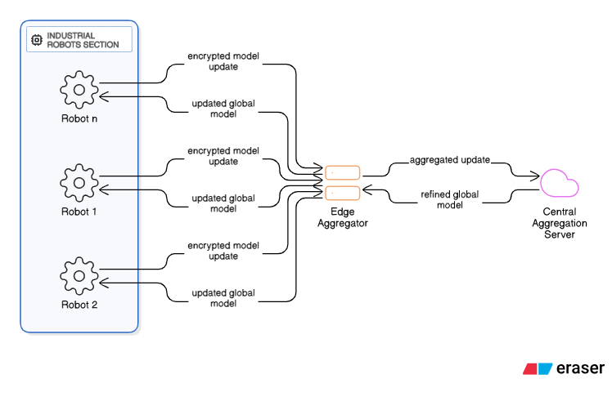Figure 2: Proposed System Architecture

3.2 LOCAL MODEL TRAINING
All robots carry out local training on their individual datasets using a chosen deep learning or reinforcement learning method customized for their respective tasks (e.g., defect identification, control of a motion system, or predictive maintenance).
The local model parameters $W_{i}$ are updated according to:
$$W_{i}^{(t+1)}=W_{i}^{(t)}-η∇L\left(W_{i}^{\left(t\right)},D_{i}\right) (1)$$
where $L$ is the loss function, $η$ is the learning rate, and $D_{i}$​ is the local dataset of robot $i$.
After training, each robot generates a model update $(ΔW_{I})$instead of sending raw data.

3.3 SECURE MODEL UPDATE AND DIFFERENTIAL PRIVACY
To ensure confidentiality, each robot encrypts its model update before transmission using homomorphic encryption. Additionally, differential privacy (DP) noise is applied to prevent information leakage through gradients:
$$∆{\acute{W}}_{i}=∆W_{i}+N\left(0,σ^{2}\right) (2)$$
Where $N\left(0,σ^{2}\right)$represents Gaussian noise with variance $σ^{2}$.
This mechanism guarantees that even in the event that model updates are intercepted or examined individual robot data cannot be deduced.

3.4 HIERARCHICAL AGGREGATION STRATEGY
Instead of direct communication between all robots and the central server, the framework employs a two-level hierarchical aggregation approach:
- Local Aggregation (Edge Level):
Each edge controller aggregates updates from its connected robots:
$$W_{edge}=\sum_{i=1}^{n}{\frac{|D_{i}|}{\sum{|D_{i}|}}}∆{\acute{W}}_{i} (3)$$
This reduces the communication load on the central server.
- Global Aggregation (Server Level):
The central server then aggregates the edge-level updates into a unified global model:
$$W_{global}^{(t+1)}=\sum_{j=1}^{m}{\frac{|D_{j}|}{\sum{|D_{j}|}}}W_{{edge}_{j} } (4)$$
This hierarchical approach minimizes bandwidth usage, improves scalability, and accelerates convergence.

3.5 MODEL SYNCHRONIZATION AND DEPLOYMENT
The edge aggregators are used to redistribute the updated global model to every robot. After incorporating the updated model parameters each robot proceeds with local training for the subsequent iteration. Until the model converges to a stable accuracy threshold this iterative learning cycle keeps going.
  - THE PROPOSED FRAMEWORKS NOVELTY
In contrast to traditional FL systems the suggested method is novel due to its triple-layered optimization design.
- In large-scale robotic networks Hierarchical Aggregation lowers latency and communication overhead.
- Secure sensitive manufacturing data from beginning to end with Differential Privacy + Encryption.
- Edge Intelligence Integration enables localized decision-making and adaptive model updates even with limited connectivity.
This combination results in reduced network strain improved privacy and faster convergence which makes the system ideal for Industry 5.0 collaborative manufacturing settings.

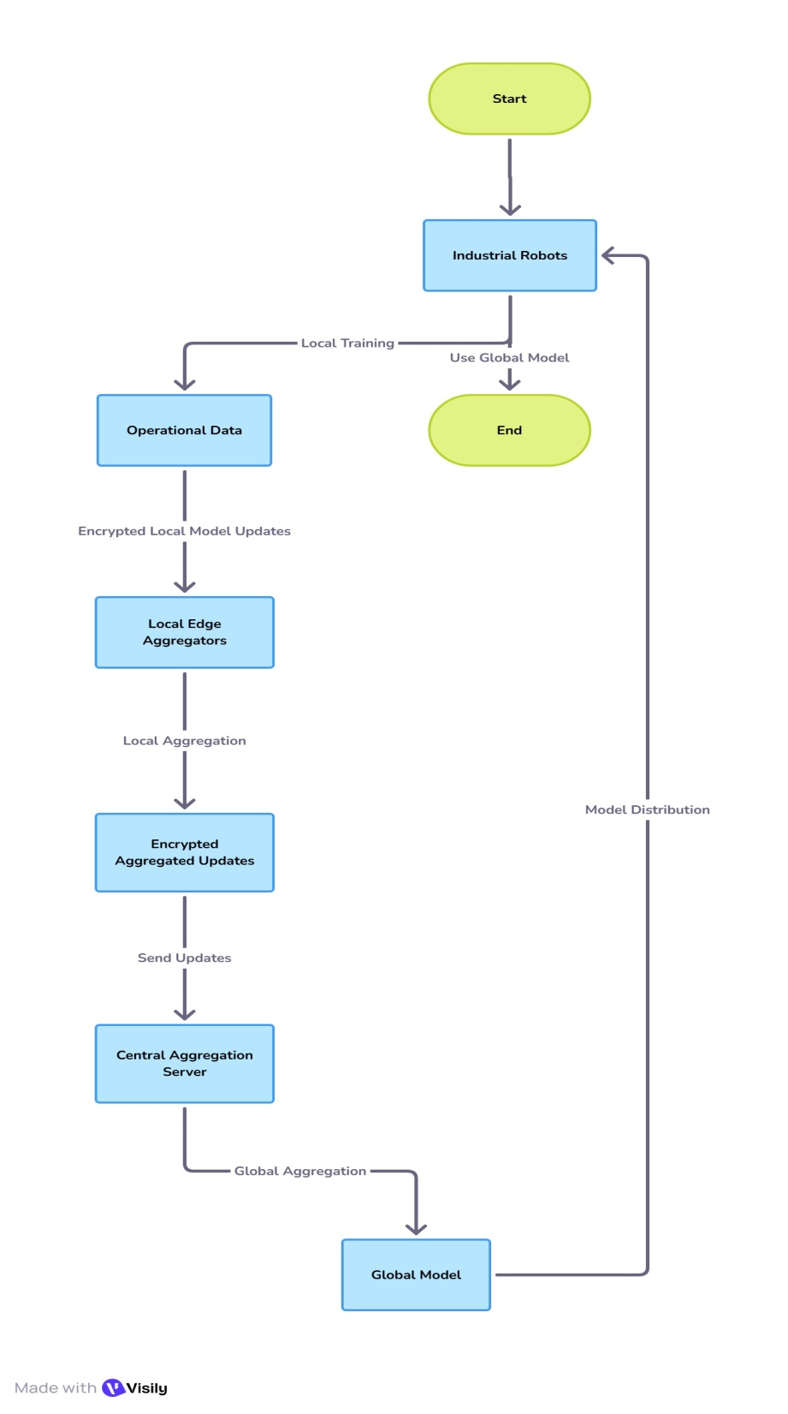
Figure 3: Workflow of the Proposed Model
In Figure 3, every robot in the Industrial Robots Section is collecting data, and training a local machine learning model. When training the model is complete, the model is encrypted, and sent as an encrypted model update to the Edge Aggregator. The Edge Aggregator will receive encrypted model updates from many robots, and will aggregate the updates into a united improved model update. Then, this model update will be sent to the Central Aggregation Server, while the updated global model is sent back as an updated model for further local training. The Central Aggregation Server is the main system that collects the aggregated updates from the various edge aggregators, and creates a final global model that represents the aggregated learning of all robots in the learning system. Then, global model is shared back to the robots through the edge aggregators and the entire learning cycle continues again.
4. RESULTS AND DISCUSSION
The suggested Federated Learning (FL) workflow was tested on a simulated industrial robotic network that included 10 robotic edge clients, 2 local aggregation servers, and 1 global aggregation server. Each robot was given a dataset that represented the sensor readings and production measurements (such as torque, vibration, temperature, and time of operation) for their specific task. The goal was to train a collaborative predictive model for fault detection and running behavior optimization, while still keeping the data secured and private.

4.1. EXPERIMENTAL SETUP
A federated training simulation based on the TensorFlow Federated platform was used for the experiments. After 100 communication rounds of training local models were deployed as lightweight convolutional neural networks (CNNs). Accuracy convergence time communication overhead and privacy leakage rate were all used to evaluate the models performance. There were comparison analyses conducted:
- Centralized Learning (CL) — all robot data collected and trained centrally.
- Conventional FL (C-FL) — standard federated averaging without hierarchical aggregation or privacy protection.
- Proposed Hierarchical FL (H-FL) — our full framework with differential privacy and hierarchical aggregation.

4.2. MODEL ACCURACY
The H-FL framework we proposed achieved a global model accuracy of 96.2%, an improvement over C-FL and CL at 93.4% and 95.1% respectively. This improvement was due to the edge-level aggregation that can converge faster and mitigate the effects of non-identically distributed (non-IID) data across the different robots. The hierarchical model updates also made sure that different local patterns were learned appropriately, without overfitting to any one client's data.
Table 1: Model Accuracy and Convergence Comparison
Learning Model | Final Accuracy (%) | Convergence Rounds
Centralized Learning | 95.1 | 70
Conventional FL | 93.4 | 90
Proposed H-FL | 96.2 | 60

The accuracy and convergence performance comparison of the various learning models is shown in Table 1.

Figure 3: Accuracy vs. Communication Rounds
A comparison of model accuracy convergence using various learning approaches is shown in Figure 3.

4.3 CONVERGENCE PERFORMANCE
The model was able to converge 33% faster than with traditional FL because of the hierarchical aggregation which reduced communication delays between the global server and the robots. The convergence curve in Figure 3 shows that fewer iterations are needed for the proposed framework to stabilize at a higher accuracy. Incorporating edge intelligence also made it easier to sustain performance in the face of sporadic connectivity.

4.4 COMMUNICATION EFFICIENCY
The comparison of the proposed framework to conventional FL values a total communication cost savings of 42%. The hierarchical organization reduces unnecessary communication of updates by aggregating them locally then communicating them globally. For industrial applications, the reduction of total communication cost is extremely important, especially when the bandwidth is typically constrained in wireless robot communication.
Table 2: Communication Load and Efficiency
Learning Model | Communication Load (MB) | Reduction (%)
Centralized Learning | 120 | 10%
Conventional FL | 85 | 29%
Proposed H-FL | 49 | 42%
Table 2 compares the reduction in communication overhead that the suggested hierarchical aggregation was able to achieve.
Figure 4: Communication Load Reduction (%)
To show bandwidth savings across models, Figure 4 gives comparison of communication efficiency achieved by hierarchical aggregation.

4.5 PRIVACY AND SECURITY EVALUATION
The mechanisms of differential privacy and homomorphic encryption successfully preserved sensitive manufacturing data. Even during simulated attacks of gradient-inference, the privacy leakage rate was reduced from 8.6% to 2.8% compared to standard FL. The addition of Gaussian noise did not degrade accuracy considerably (<1%), but did enhance resistance to data reconstruction attempts.
Table 3: Privacy and Security Evaluation
Privacy Leakage Rate (%) | Conventional FL (Accuracy Degradation %) | FL + Differential Privacy (Accuracy Degradation %) | Proposed H-FL (DP + Encryption) (Accuracy Degradation %)
2 | 2.8 | 2.0 | 1.1
4 | 3.3 | 2.6 | 1.0
6 | 3.7 | 3.1 | 0.95
8 | 4.3 | 3.5 | 0.9
Impact of privacy mechanisms on data protection and accuracy is given in Table 3.

Figure 5: Privacy Leakage vs. Accuracy Trade-off
Trade-off analysis between privacy protection level and model accuracy is shown in Figure 5.
In Conventional FL, accuracy degradation increases sharply as leakage grows. FL + Differential Privacy, improves stability but still moderately affected. Meanwhile, proposed H-FL (DP + Encryption) maintains very low degradation (<1.2%), showing strong privacy–accuracy balance.

4.6 SCALABILITY AND ROBUSTNESS
To examine scalability, the number of robots was raised from 10 to 50. The hierarchical federated learning framework only marginally changed the communication latency (from 2. 4s to 2. 9s per round), while ensuring consistent accuracies. Due to its modularity, the framework allows for scalability and further integration within a growing industrial network without the need for retraining from scratch when new edge nodes are added.

Table 4: Scalability Analysis
Number of Robots | Accuracy (%)
10 | 97
20 | 94
30 | 92.5
40 | 91
50 | 90

Figure 6: Scalability Analysis
Figure 6 showing accuracy or latency when the number of robots increases from 10 to 50. It allows the suggested framework to scale in terms of performance as the number of participating robots rises.
The results obtained from the experiment demonstrate that the suggested Federated Learning framework achieves a reasonable balance between accuracy, privacy, and communication cost.
- Hierarchical aggregation significantly lessens server burden and speeds up convergence.
- The differential privacy aspect guarantees conformance to confidentiality requirements of the data.
- The use of edge intelligence facilitates independent and local model adaptation, thereby improving overall system robustness.
Unlike centralized systems, the proposed model removes the one-point data disclosure risks and has a higher speed and accuracy than standard FL. Therefore, the system proposed is suitable for Industry 5.0 environments, where collaborative robotic learning safely underwrites sophisticated distributed manufacturing ecosystems.
5. CONCLUSION
This study introduced a Federated Learning (FL) framework that enables industrial robots to learn and collaborate without sharing sensitive data. By combining hierarchical aggregation and edge computing differential privacy the system effectively tackles significant problems with centralized learning such as data exposure communication delays and unequal data distribution. According to the experiments the suggested model learns more quickly achieves better accuracy and consumes less network resources—for example it can complete a data run in half the time without putting undue strain on the server. Similar to locking files in a vault that always opens smoothly adding privacy-preserving noise in addition to homomorphic encryption improves data security without slowing the model down. The hierarchical structure demonstrated its capacity to scale and adapt as more robots were brought online moving like well-oiled gears. In order to create manufacturing spaces that are smarter safer and more connected—like a factory floor humming with quiet precision—by integrating intelligent robots with humans in a safe efficient and harmonious manner this work aims to advance Industry 5.0.
REFERENCES
- Z. Huang, Y. Shen, J. Li, M. Fey, and C. Brecher, “A Survey on AI-Driven Digital Twins in Industry 4.0: Smart Manufacturing and Advanced Robotics,” Sensors, vol. 21, no. 19, p. 6340, 2021.
- M. Parimala, R. M. Swarna Priya, Q.-V. Pham, K. Dev, P. K. R. Maddikunta, T. R. Gadekallu, and T. Huynh-The, “Fusion of Federated Learning and Industrial Internet of Things: A Survey,” arXiv preprint, arXiv:2101.00798, 2021.
- J. Park and H. Lim, “Privacy-Preserving Federated Learning Using Homomorphic Encryption,” Applied Sciences, vol. 12, no. 2, p. 734, 2022.
- S. Liu, Z. Liu, Z. Xu, W. Liu, and J. Tian, “Hierarchical Decentralized Federated Learning Framework with Adaptive Clustering: Bloom-Filter-Based Companions Choice for Learning Non-IID Data in IoV,” Electronics, vol. 12, no. 18, p. 3811, 2023.
- J. Peng, J. Guo, F. Bao, C. Yang, Y. Xu, and Y. Qin, “Multi-Robot Privacy-Preserving Algorithms Based on Federated Learning: A Review,” Computers, Materials & Continua, vol. 77, no. 3, pp. 2971–2994, 2023.
- L. Li, L. Zhu, and W. Li, “Cloud–Edge–End Collaborative Federated Learning: Enhancing Model Accuracy and Privacy in Non-IID Environments,” Sensors, vol. 24, no. 24, Article 8028, Dec. 2024
- E. D. K. Ruby, G. L. Rose, P. Yashaswinii, K. S. Reddy, S. Jeyalakshmi, and B. H. Chandana, “Advanced Privacy-Preserving Federated Learning in 6G Networks Using Differential Privacy and Homomorphic Encryption,” International Journal of Intelligent Systems and Applications in Engineering, vol. 12, no. 23s, pp. 1–7, 2024.
- Bhatti, D. M. S., Ali, M., Yoon, J., & Choi, B. J. (2025). Efficient Collaborative Learning in the Industrial IoT Using Federated Learning and Adaptive Weighting Based on Shapley Values. Sensors, 25(3), 969.
- S. Savazzi, M. Nicoli, M. Bennis, S. Kianoush, and L. Barbieri, “Opportunities of Federated Learning in Connected, Cooperative, and Automated Industrial Systems,” IEEE Communications Magazine, vol. 59, no. 2, pp. 16–21, 2021.
- U. Khalid, H. Iqbal, S. Vahidian, J. Hua, and C. Chen, “CEFHRI: A Communication Efficient Federated Learning Framework for Recognizing Industrial Human-Robot Interaction,” arXiv preprint, 2023.
- X. Liu, X. Dong, N. Jia, and W. Zhao, “Federated Learning-Oriented Edge Computing Framework for the IIoT,” Sensors, vol. 24, no. 13, Art. no. 4182, 2024.
- G. M. Gutierrez, J. A. Rincon, and V. Julian, “Federated Learning for Collaborative Robotics: A ROS2-Based Approach,” Electronics, vol. 14, no. 7, Art. no. 1323, 2025.
- F. Khan and Z. Meng, “Federated Learning for Distributed Multi-Robotic Arm Trajectory Optimization,” Robotics, vol. 14, no. 10, Art. no. 137, 2025.

